**GOVERNMENT COLLEGE OF ENGINEERING [IRTT]**

**ERODE: 638 316**



**Electronics and Communication Engineering**

**NAAN MUDHALVAN**

**DIGITAL MARKETING**

**ASSIGNMENT**

NM ID: 802393DE32E48ED954E4171EA7A66E3D

NAME: NIRMALA DEVI G

*BRAND NAME: SUNFEAST*

*CATEGORY: COOKIES BRAND*

1. Create a blog or website using Blogspot and WordPress. Customize the theme design and post new article with 500 words.

Link: Blog using Blogspot

<https://sunfeastmadurai.blogspot.com>

Screenshot:

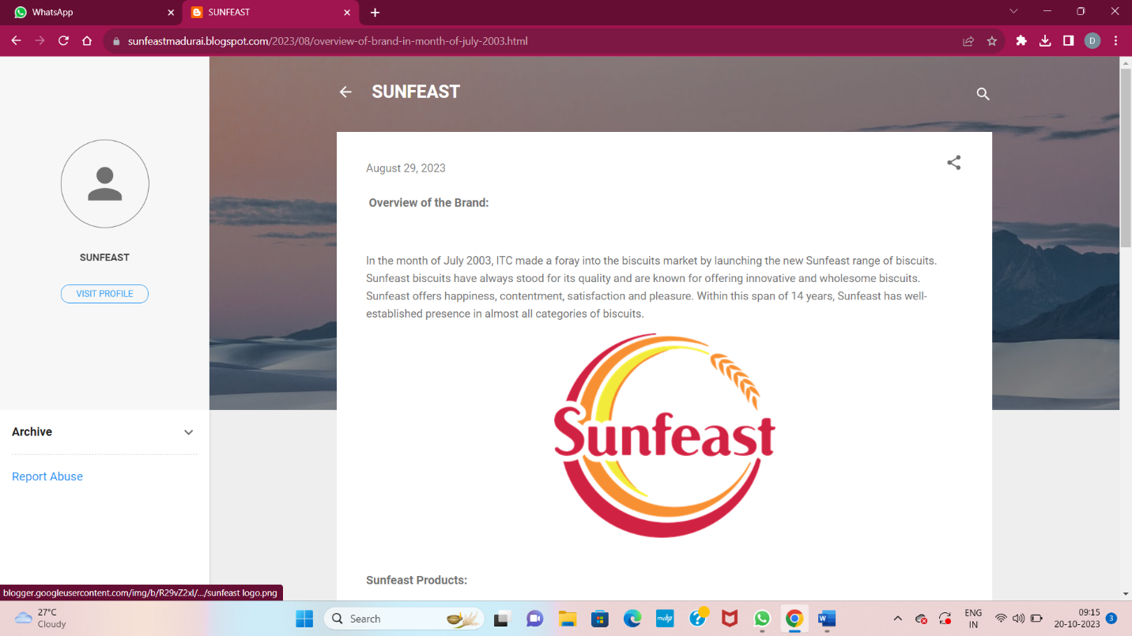

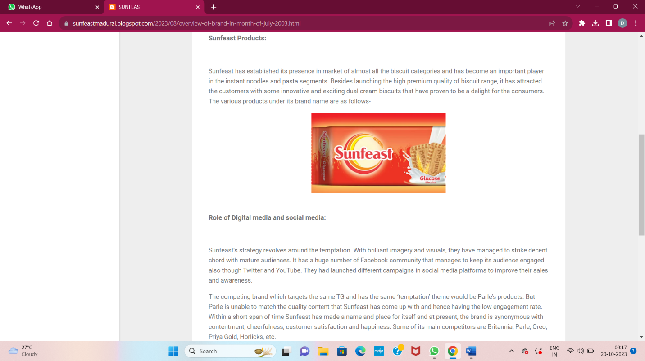

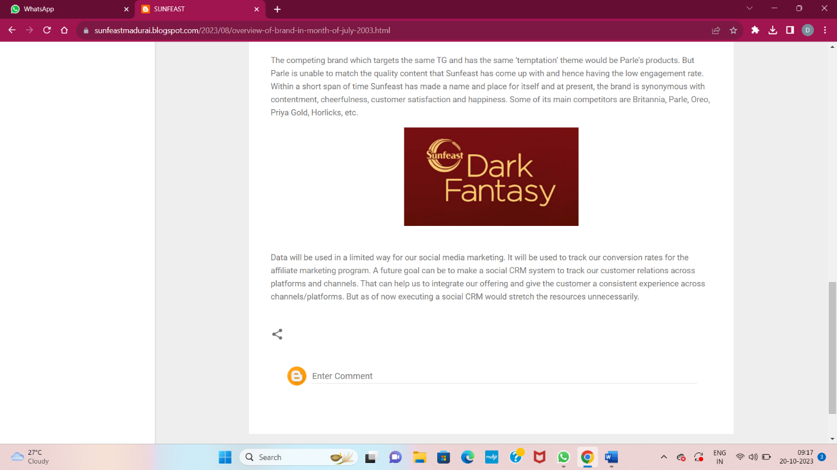

2.Create a New Facebook Business Page and post one social media poster for your brand.

Link: Facebook business page

<https://www.facebook.com/profile.php?id=61552358680370&mibextid=ZbWKwL>

Screen shot:

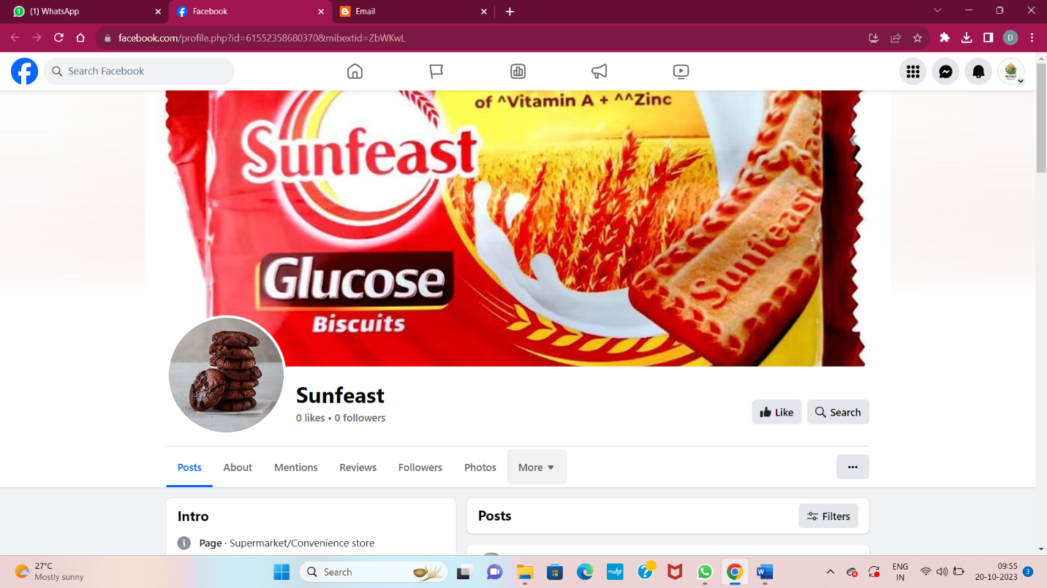

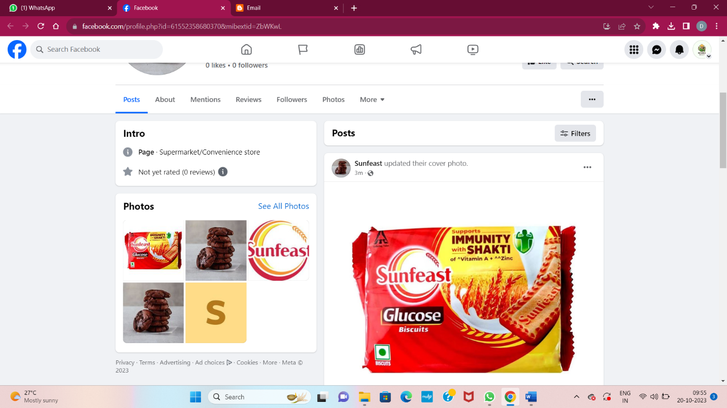

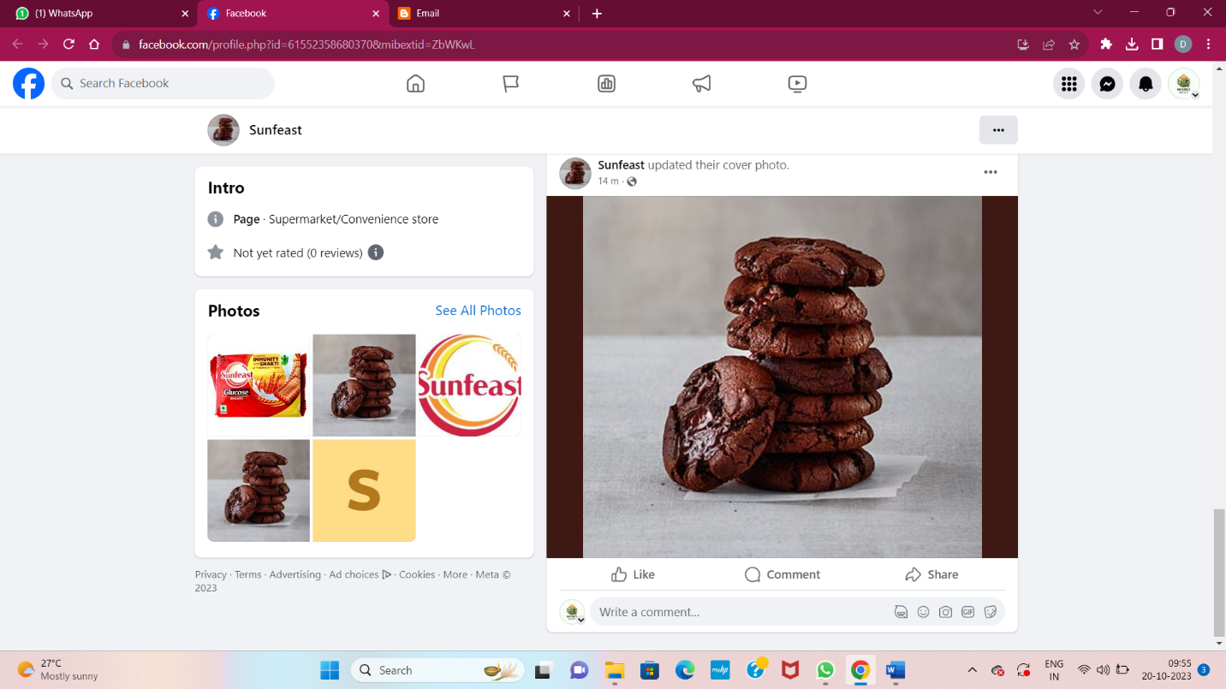

3.Create and design a social media advertisement poster using canva.

Link:

<https://sunfeastmadurai.blogspot.com/2023/09/infographics.html>

Screenshot :

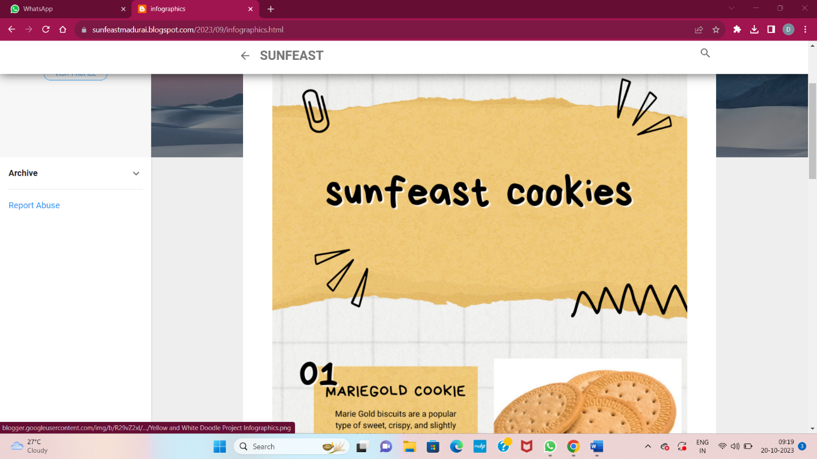

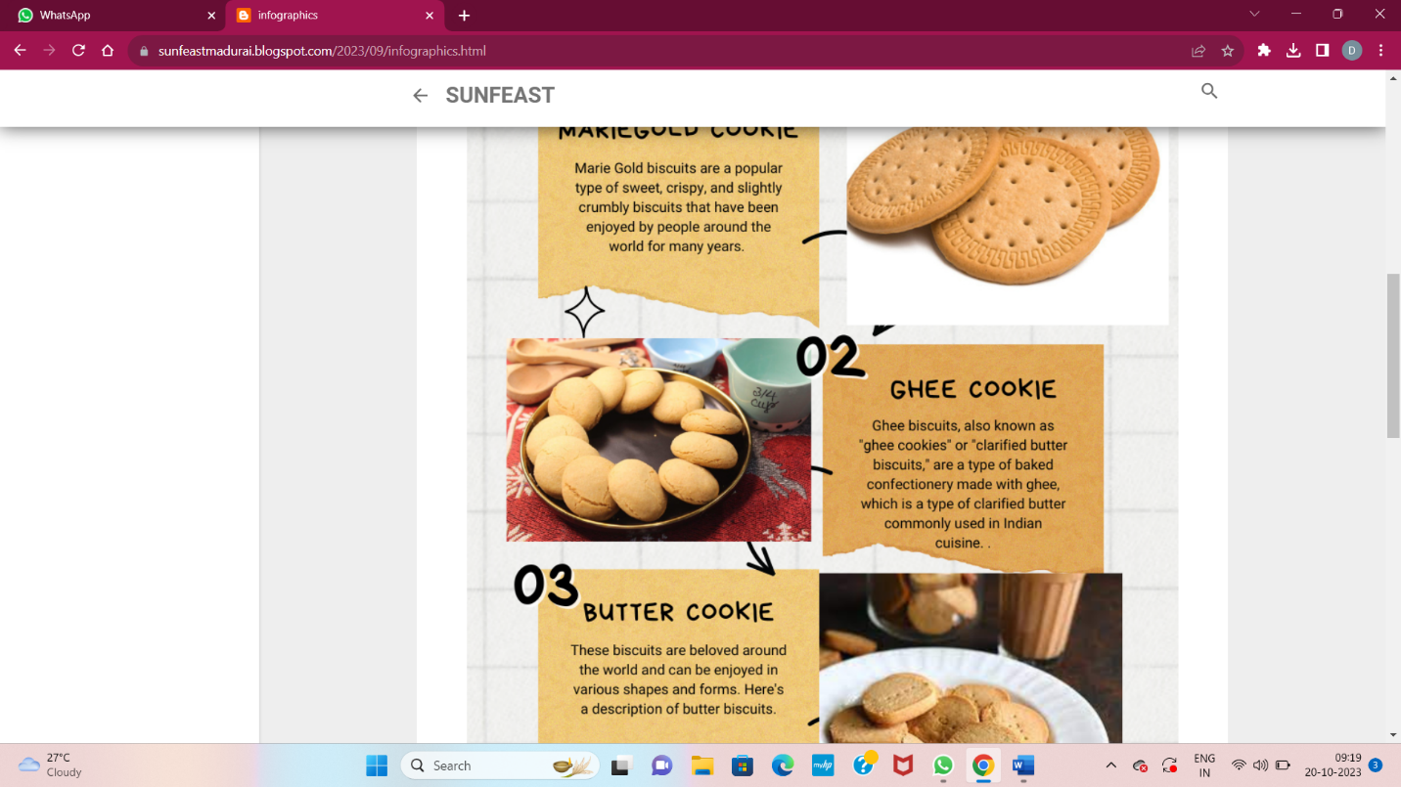

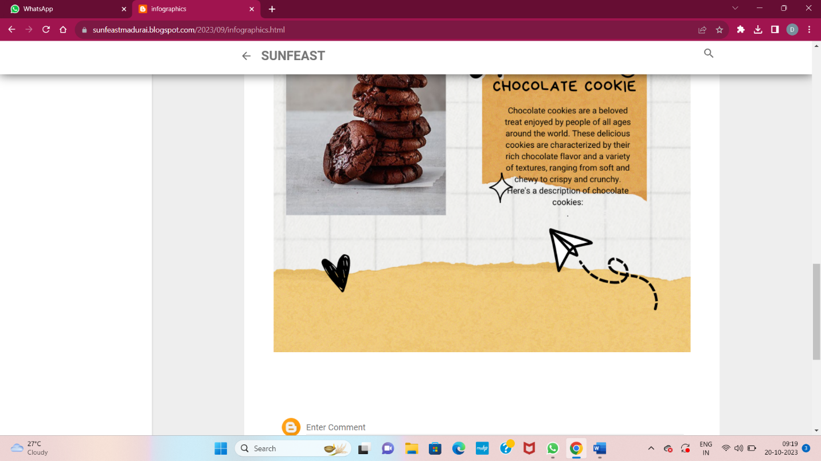

4.Create email newsletter design using MailChimp or canva tool.

Link: Email newsletter design using canva

<https://sunfeastmadurai.blogspot.com/2023/09/email.html>

screen shot:

